Docker Containerization  
CS 470 Full Stack Development II

Sergio Mateos

Southern New Hampshire University

1. Graphical user interface, text, application

   Description automatically generatedFork Angular Project.
2. Text

   Description automatically generatedClone Angular repo.
3. Text

   Description automatically generatedInstall nvm.

1. Text

   Description automatically generateddocker build -t node-lafs-web

1. Text

   Description automatically generateddocker run -p 4200:4200 -d node-lafs-web

1. 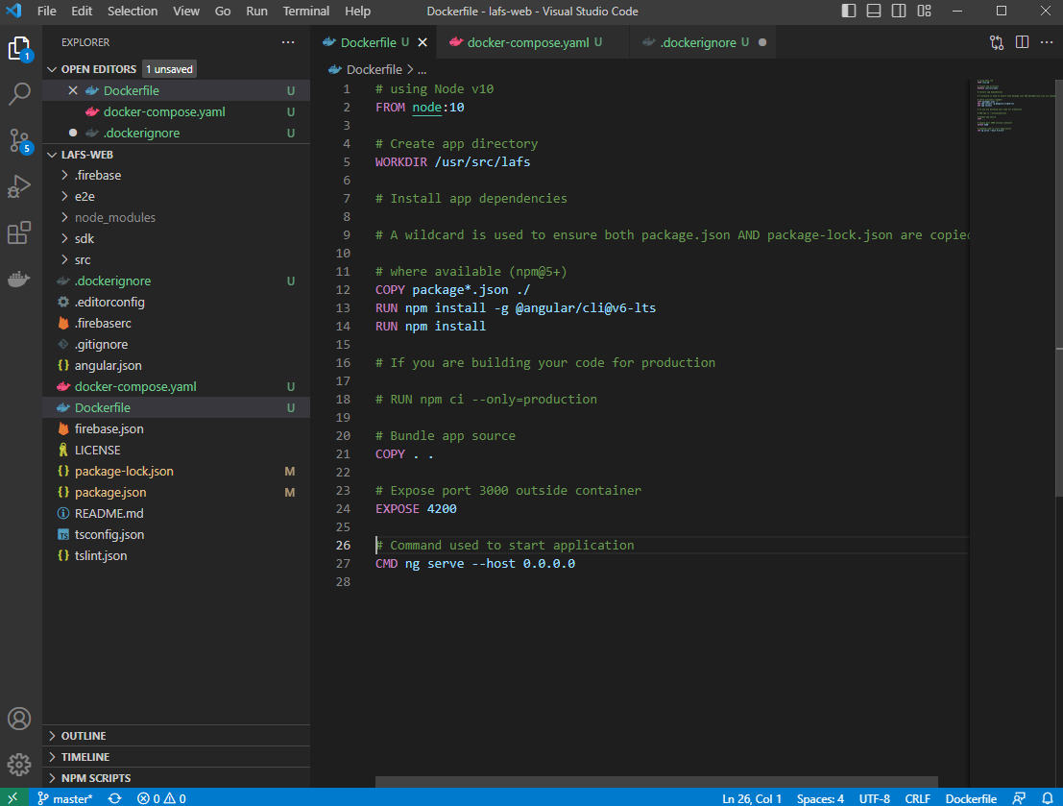Dockerfile

**Backend REST API**

1. Graphical user interface

   Description automatically generatedText

   Description automatically generatedClone
2. Text

   Description automatically generatedDockerfile

